

Foundations of Programming

Assignment No.: 14
PROBLEM STATEMENT: Write a C program to input a binary number from the user and convert it into a decimal number.

OBJECTIVE:

- To understand number system conversions.
- To learn how to convert binary numbers to decimal numbers in C.
- To practice the use of loops and arithmetic operations.
- To develop logical thinking for number system problems.

THEORY:
A binary number system uses only two digits: 0 and 1. Each digit of a binary number represents a power of 2 depending on its position. To convert a binary number into its decimal equivalent, each digit is multiplied by 2 raised to the power of its position and the results are added together. In C programming, this conversion can be implemented using loops and arithmetic operations.

ALGORITHM:
Step 1: Start
Step 2: Declare variables bin, res, base & rem and take bin as an input from the user.
Step 3: Store the original input in temp.
Step 4: while (temp > 0)
- rem = temp % 10;
- res = res + rem * base;
- temp /= 10;
- base *= 2;
Step 5: Display result in res.
Step 6: Stop.

FLOWCHART:
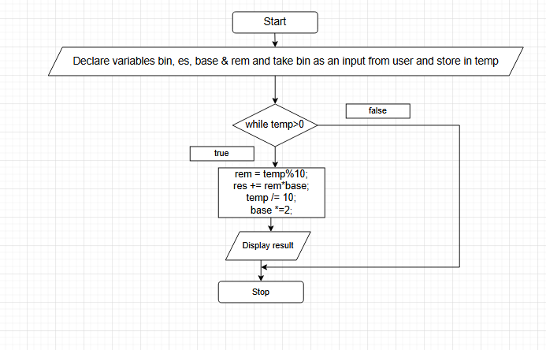

CODE:
#include <stdio.h>

int main() {
int bin, temp, rem;
int res = 0;
int base = 1;

printf("Enter a binary number: ");
scanf("%d", &bin);

temp = bin; // Store original input

while (temp > 0) {
rem = temp % 10;
res = res + rem * base;
temp = temp / 10;
base = base * 2;
}

printf("Decimal equivalent is: %d", res);

return 0;
}
PLATFORM: Linux

INPUT: 101.

OUTPUT: 5
CONCLUSION: Thus, the C program successfully converts a binary number entered by the user into its decimal equivalent using loops and arithmetic operations.

FAQs:
- What is a binary number system?
- How is a binary number converted into a decimal number?
- What is the role of loops in binary to decimal conversion?
- What is the role of the pow() function in this program?
- What is the data type used to store binary and decimal numbers in this program?

